**Item Receipt Inspection (Review and Approve/Reject)**

Process Flow:

1. Item record – mark item for inspection  
   - Item record >For Inspection check box is available

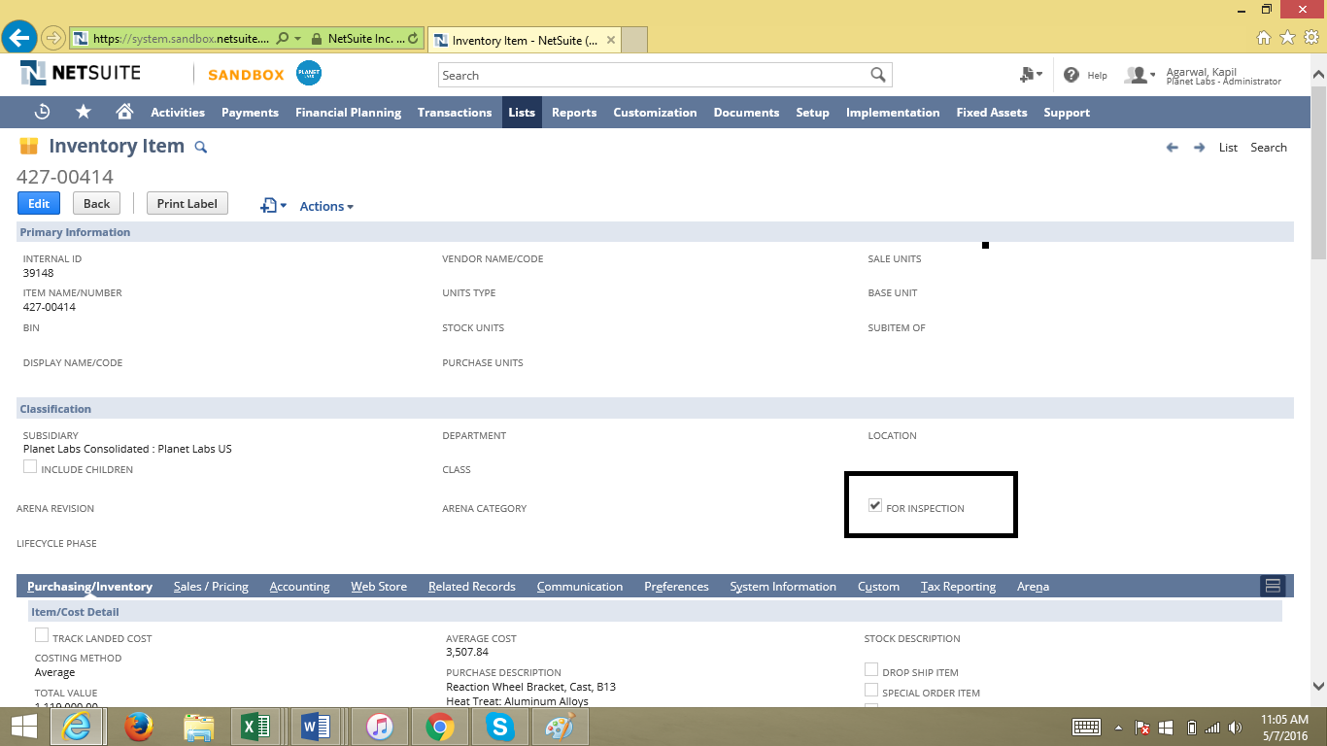

1. On Purchase Order, items marked for inspection will go through review and approval/rejection process

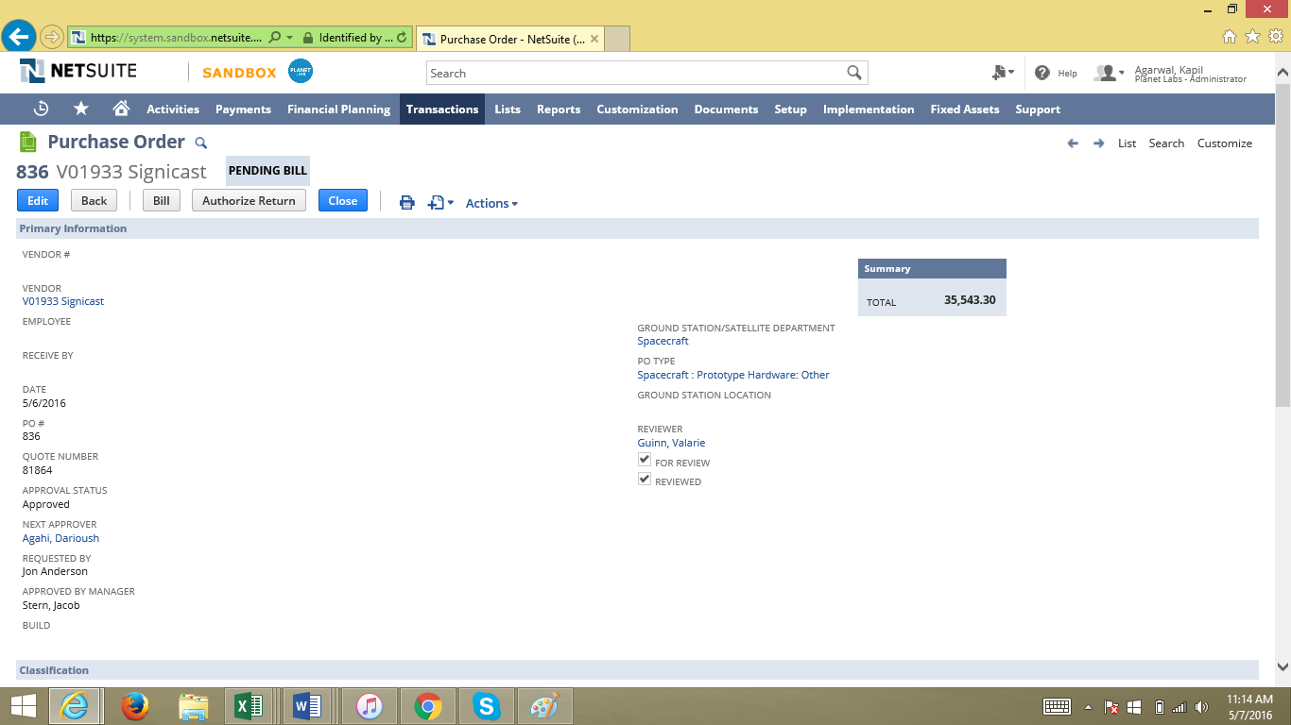

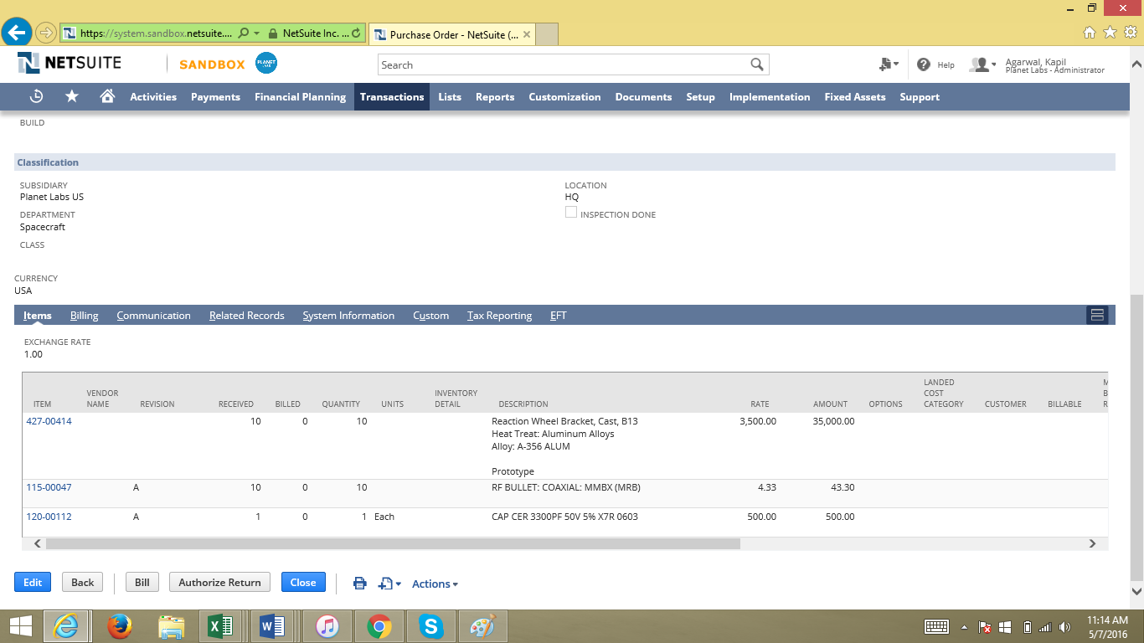

Items:  
[427-00414](https://system.sandbox.netsuite.com/app/common/item/item.nl?id=39148) – Marked for inspection  
[115-00047](https://system.sandbox.netsuite.com/app/common/item/item.nl?id=25014) – Marked for inspection and item set to use bins  
[120-00112](https://system.sandbox.netsuite.com/app/common/item/item.nl?id=18732) – Is not marked for inspection

Item 120-00112:

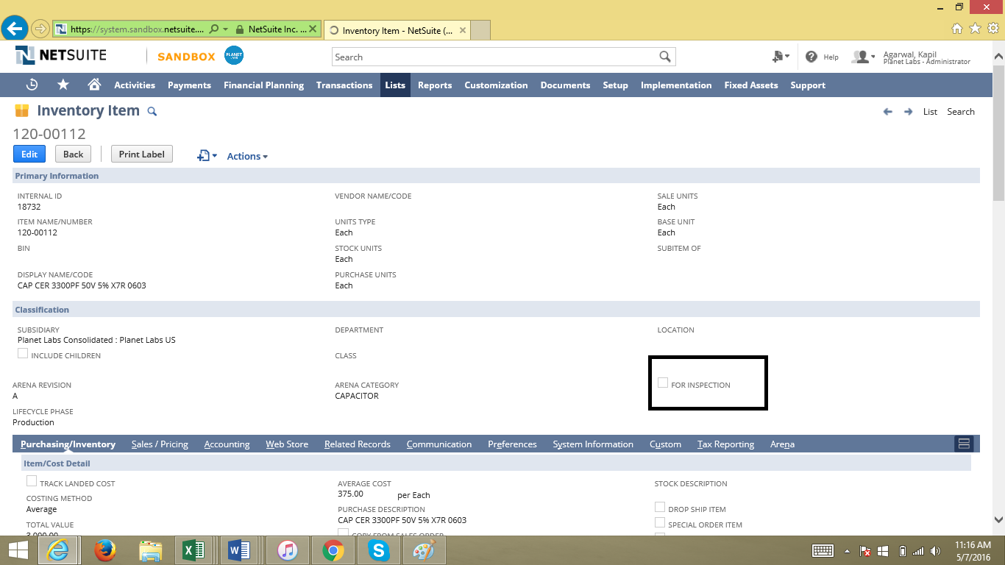

1. Receive the purchase order

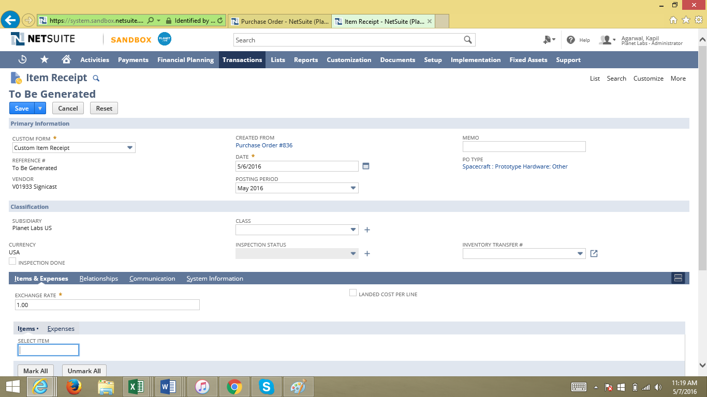

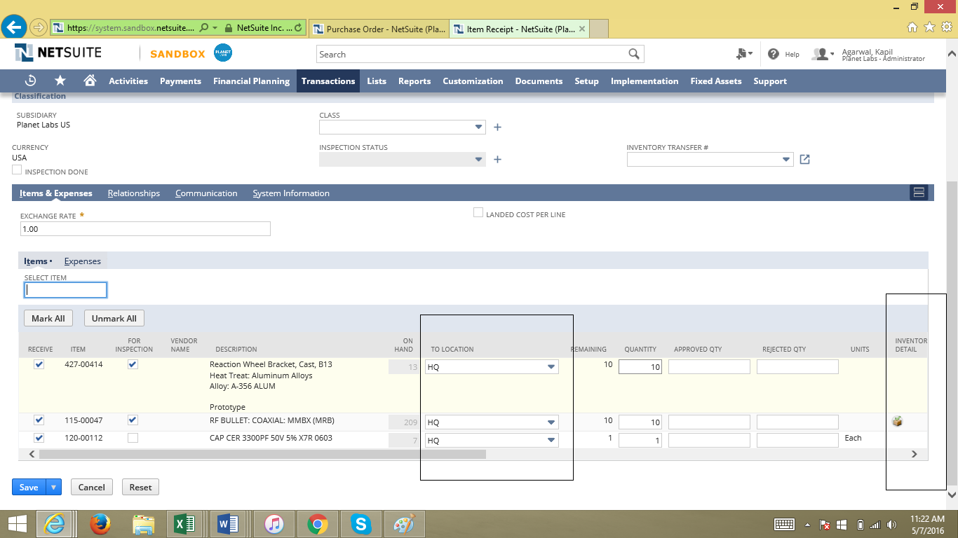

On the item receipt, see below:  
- To Location is auto set to copy from PO  
- For Inspection – this will source from item and users will not be able to change value here  
- Inventory Detail – set a bin number and enter the Qty  
***Select only one bin for each item

Save the item receipt

1. The item receipt after save :  
   > Submit for Inspection button will be available  
   > To Location – Inspection Location for items marked for approval/rejection  
   > Item 3: [120-00112](https://system.sandbox.netsuite.com/app/common/item/item.nl?id=18732) – is showing under HQ Location since this will not go through inspection

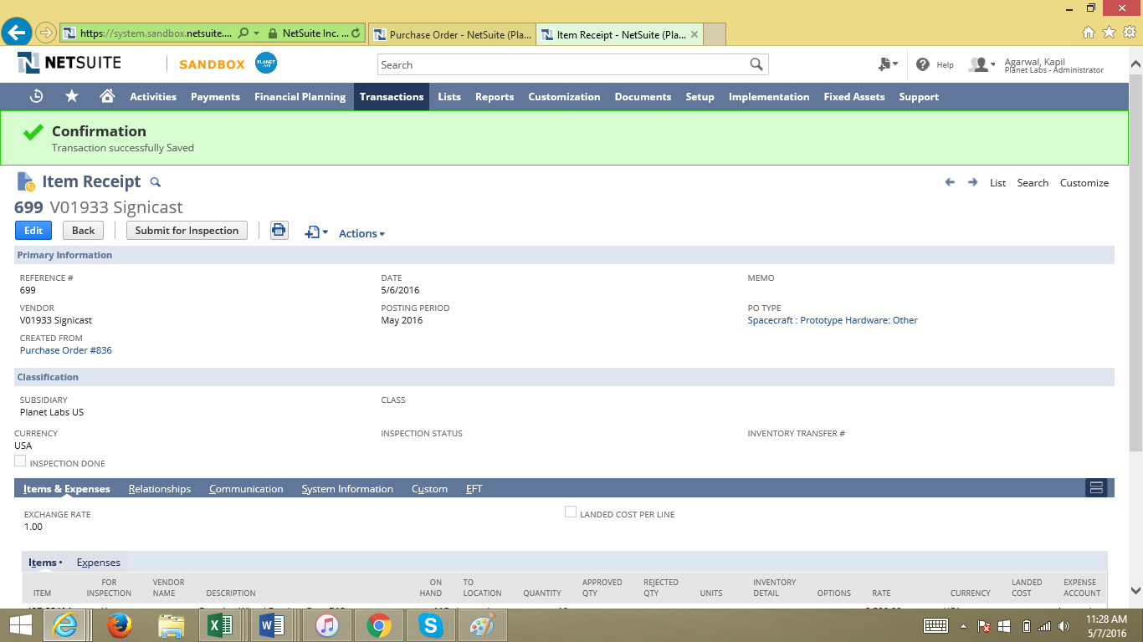

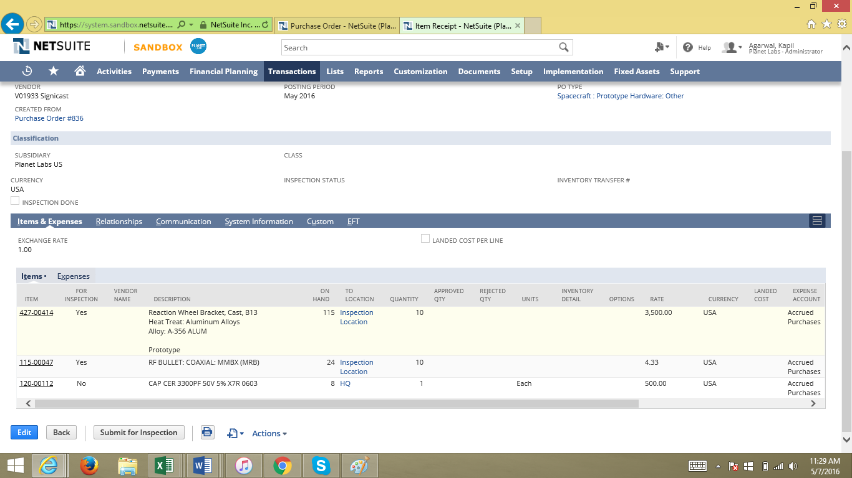

1. Submit for Inspection – submit the IR for inspection (click on the button)  
   > GL Impact reversal on Item Receipt when Inspection Status = Pending Approval  
   > The GL impact after submission is below:

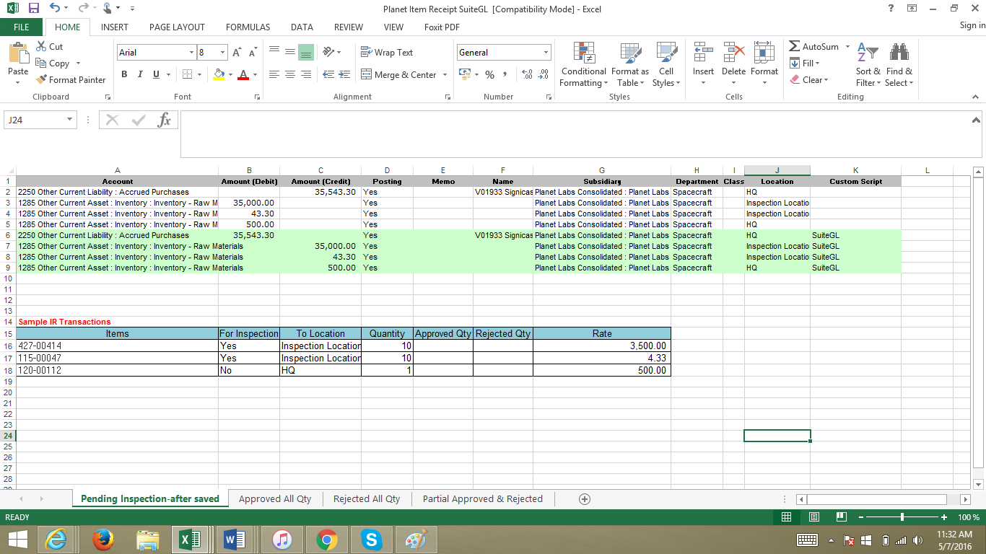

1. Approve ALL items on the item receipt: (SCENARIO 1)

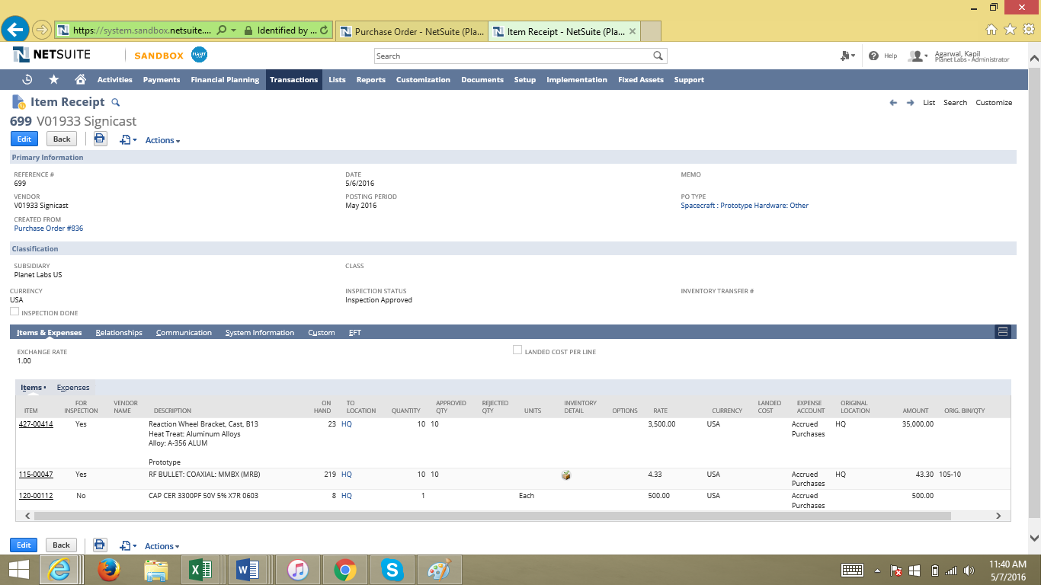

* To Location – is now back to the original and same as the Purchase Order
* Item 2: [115-00047](https://system.sandbox.netsuite.com/app/common/item/item.nl?id=25014) Inventory Detail - the bin is assigned back to the Item Receipt
* After approval, the script will reclass the Asset Account to Expense selected on the PO Type field
* The GL Impact after approving all items:

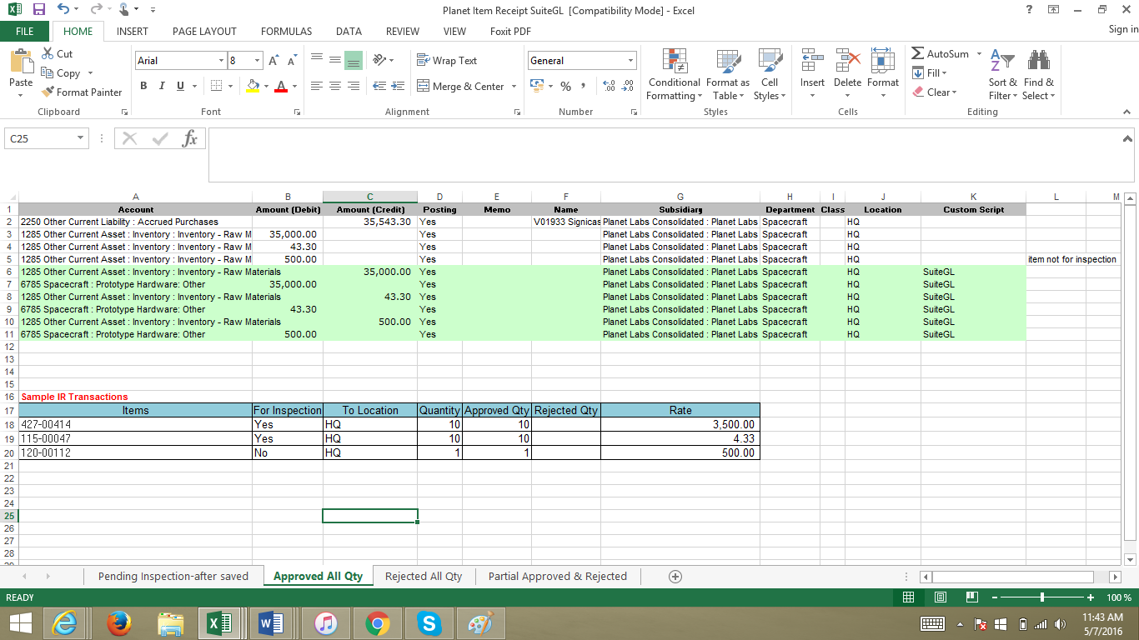

SCENARIO 2: If all items are rejected:  
a. Purchase Order #849  
> Same items as above

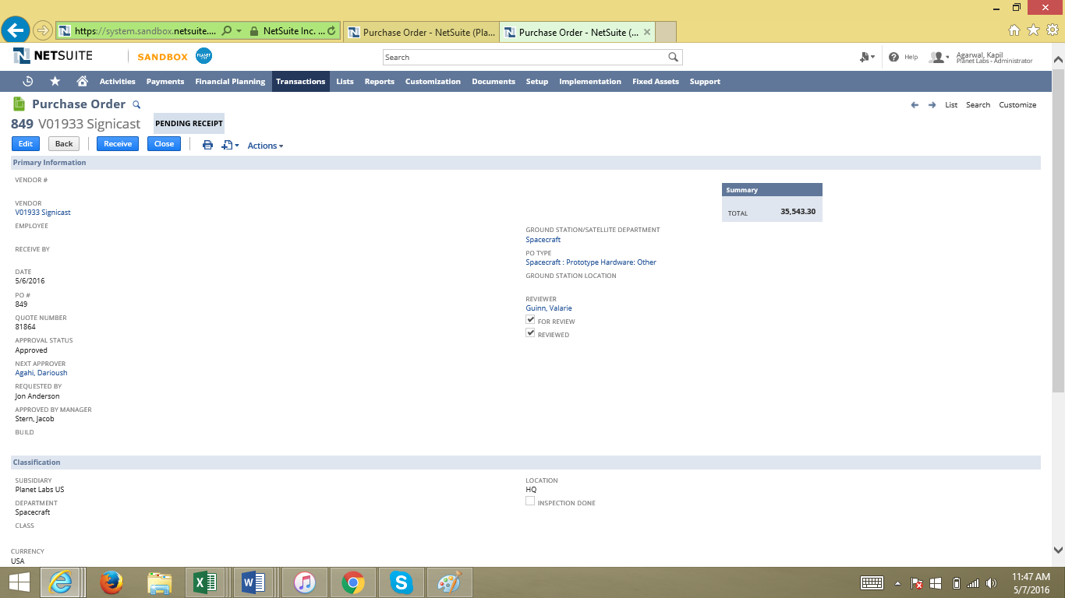

b. Receive the item – same process above

c. Submit for Inspection - same process above

d. Item Receipt after inspection

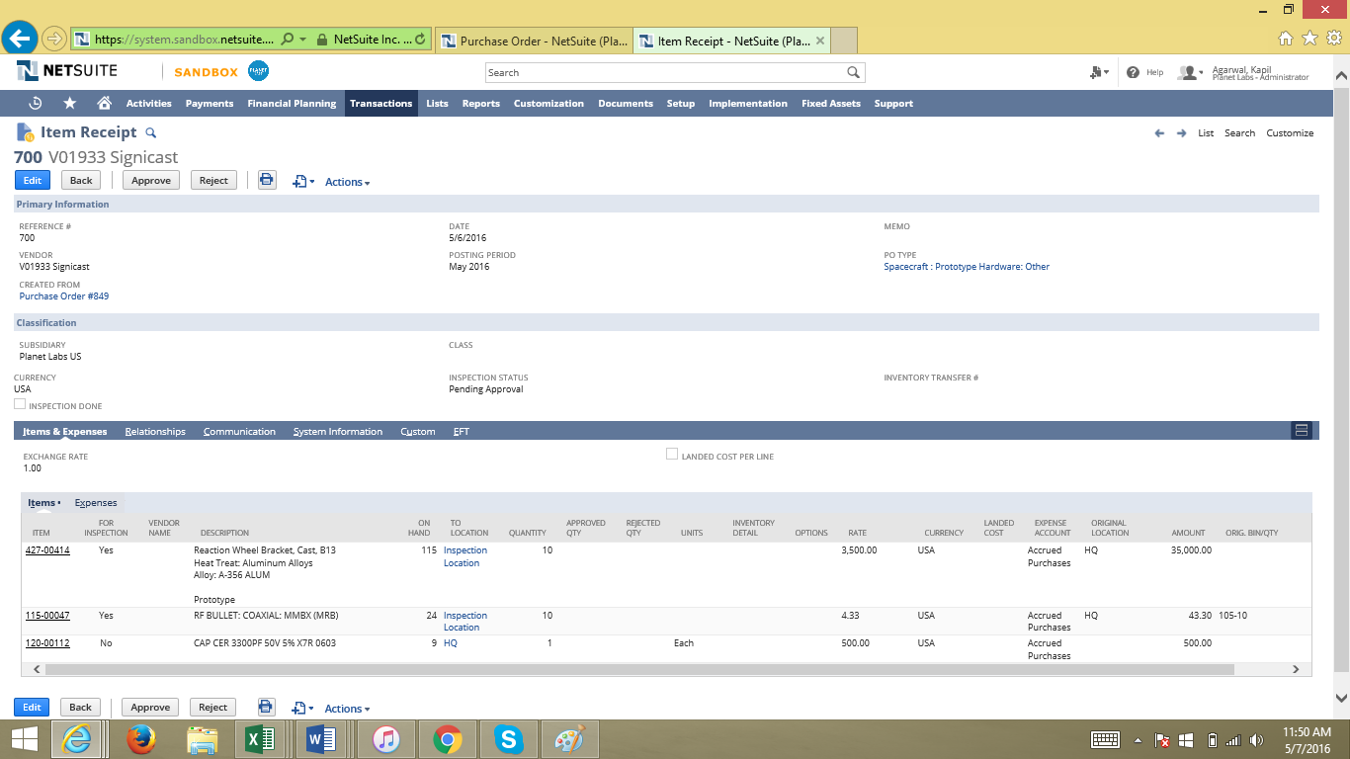

Reject the IR:  
> To Location – show under RMA for items marked for inspection  
> Item 3: [120-00112](https://system.sandbox.netsuite.com/app/common/item/item.nl?id=18732) shows in HQ Location since this is not part of the inspection

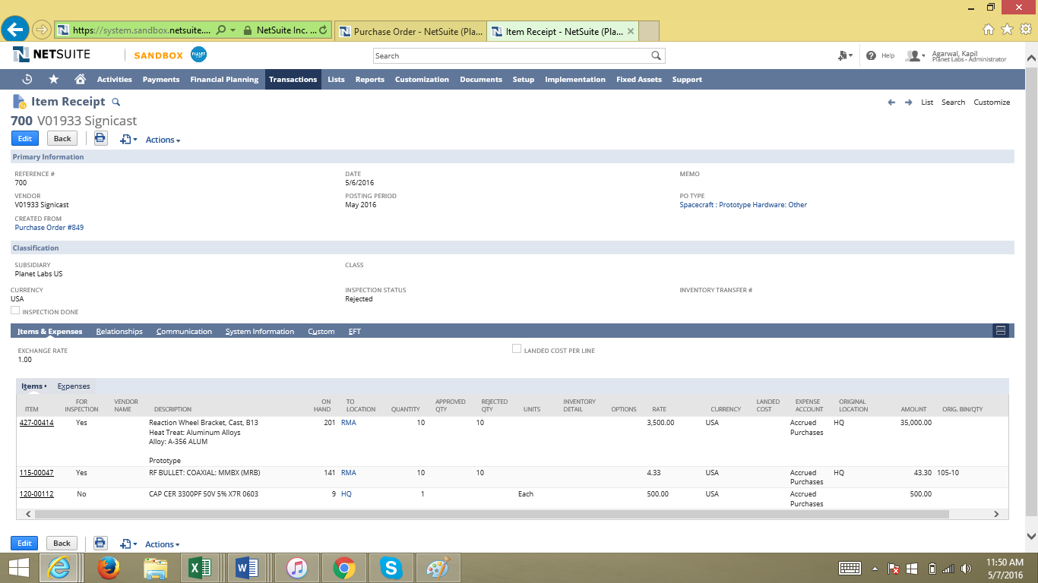

GL Impact after reject:  
- Reverse all rejected items  
- Items not for inspection (item 3: 120-00112) is reclass from Asset to Expense based on PO Type

**See spreadsheet for the GL impact : file name Planet Item Receipt SuiteGL

SCENARIO 3: Partial Approved and Rejected  
a. Purchase Order no 850  
> Same items as previous sample PO

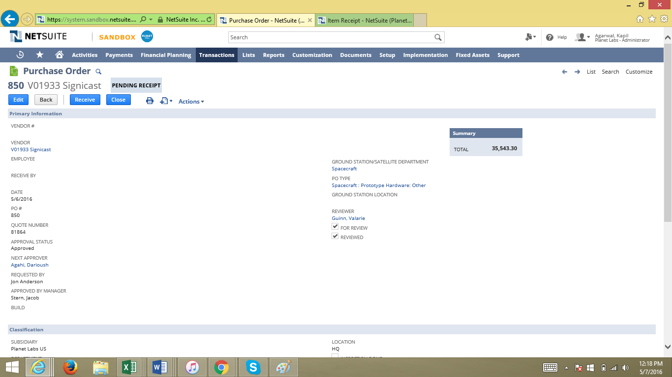

b. Same process from previous scenarios :  
> Receive the purchase order to create item receipt

c. Submit for Inspection - same process above

d. Item Receipt after inspection

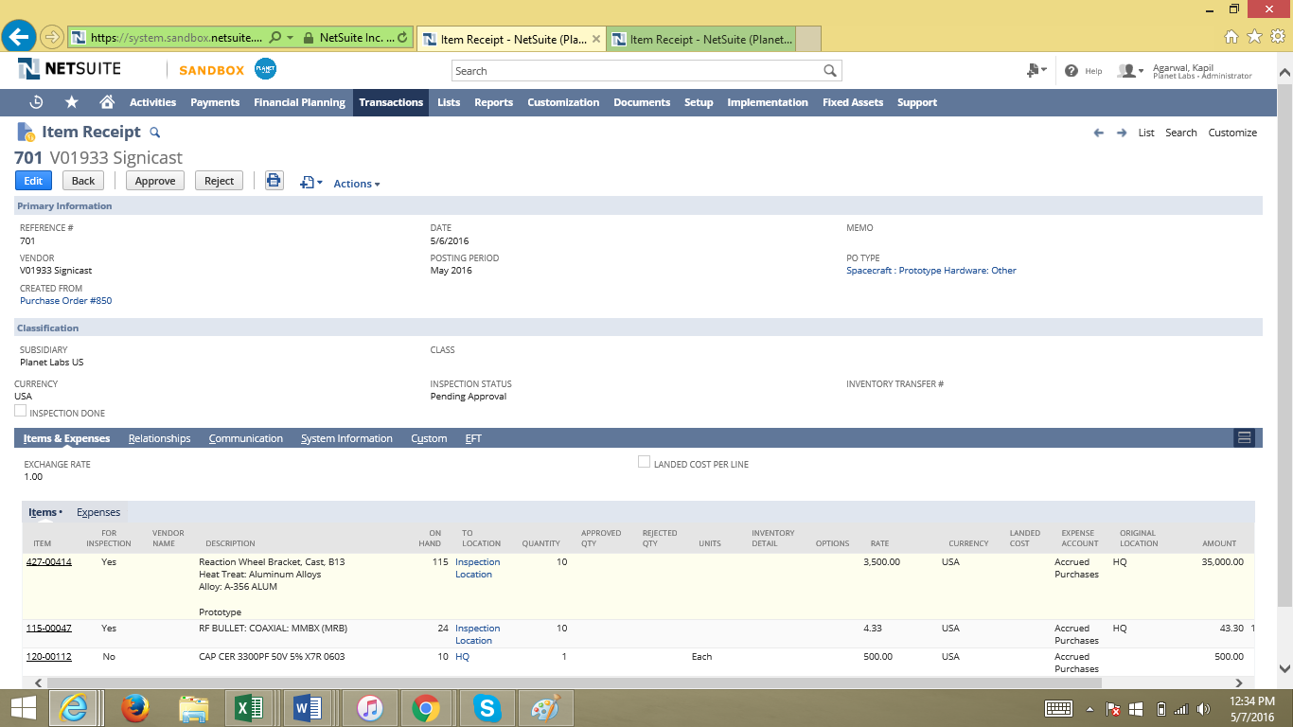

e. Approver to edit the IR and set the approved and rejected qty. See sample IR below with the approved and rejected items:

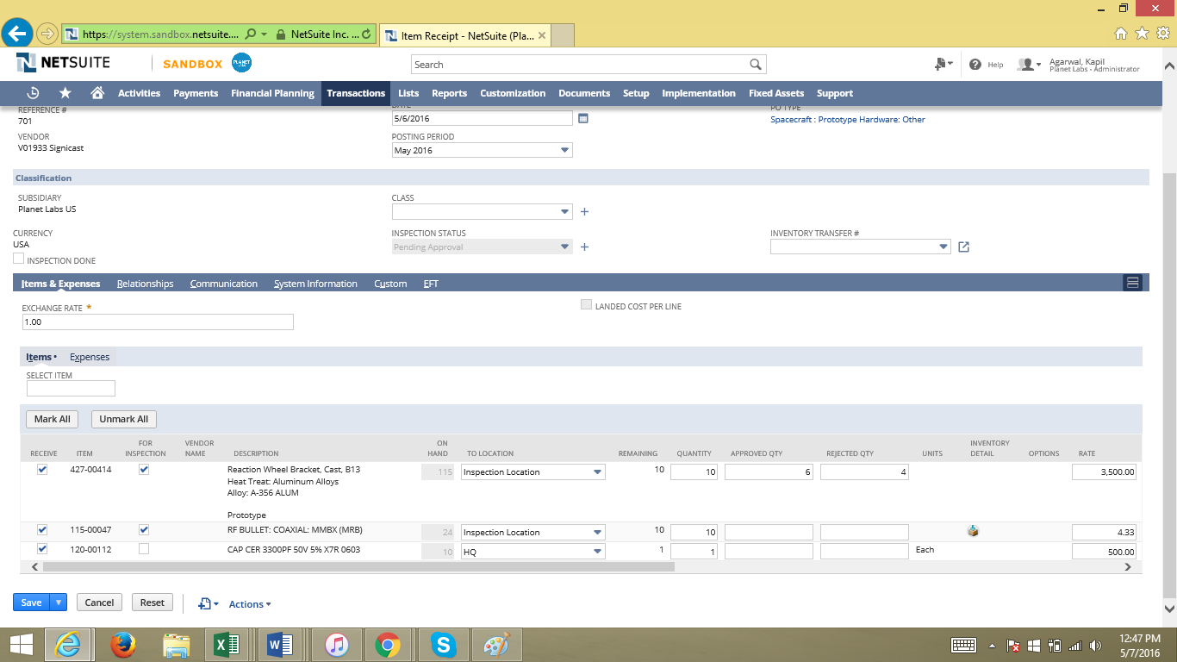

After saving the item receipt, click on the Approve button

The IR is below:

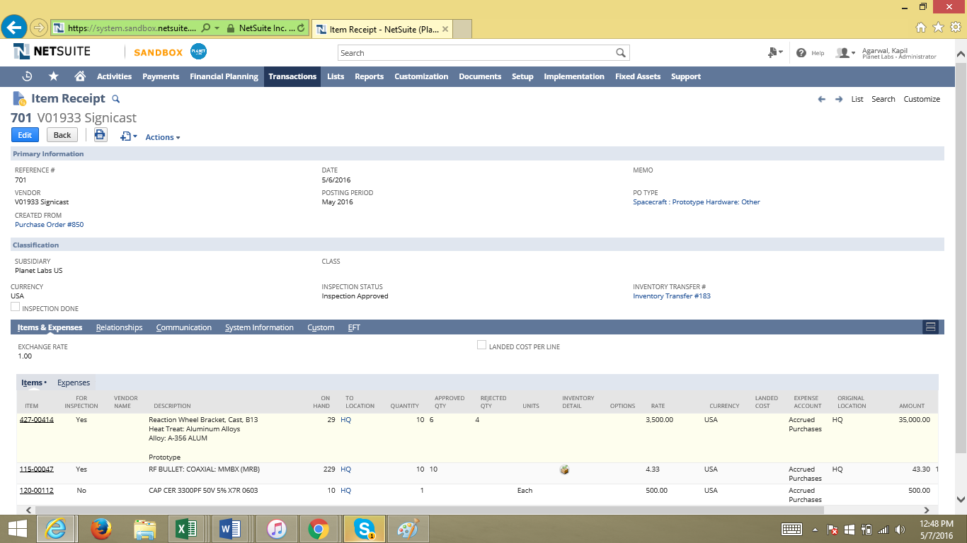

* To Locations are all in HQ (The rejected items will be recorded under RMA location on the inventory transfer 183)
* The GL Impact is below:

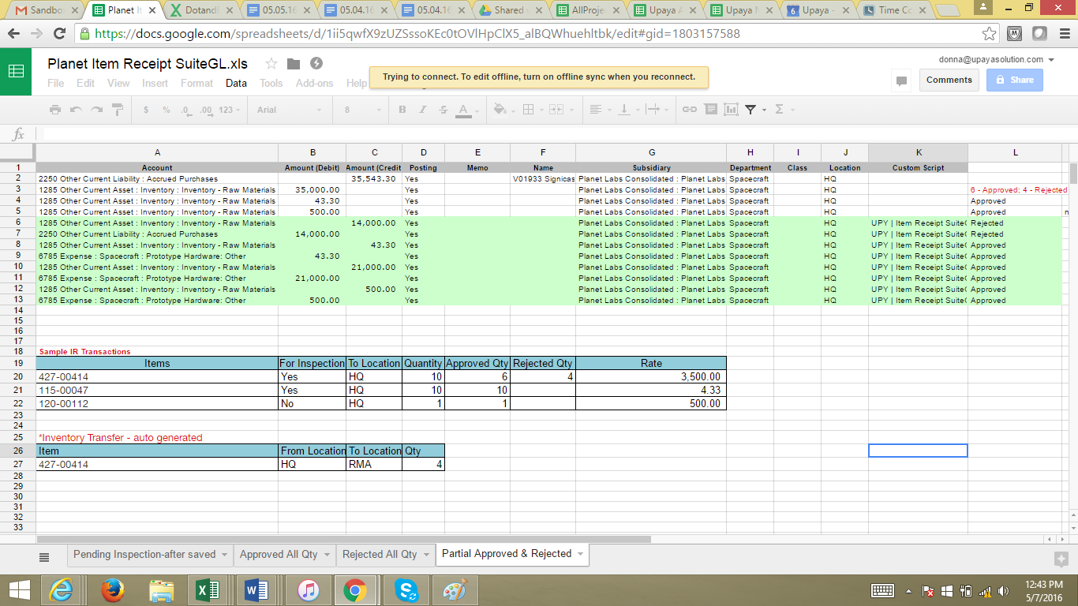

Rows 6 and 7 – This is the rejected items. Reversing the GL impact of the item

Rows 8 to 11 – These are the approved items being reclass from asset to expense based on PO Type

Rows 12 and 13 – This is the item that did not go for inspection and still was reclass to expense

The inventory transfer auto created to transfer location to RMA:

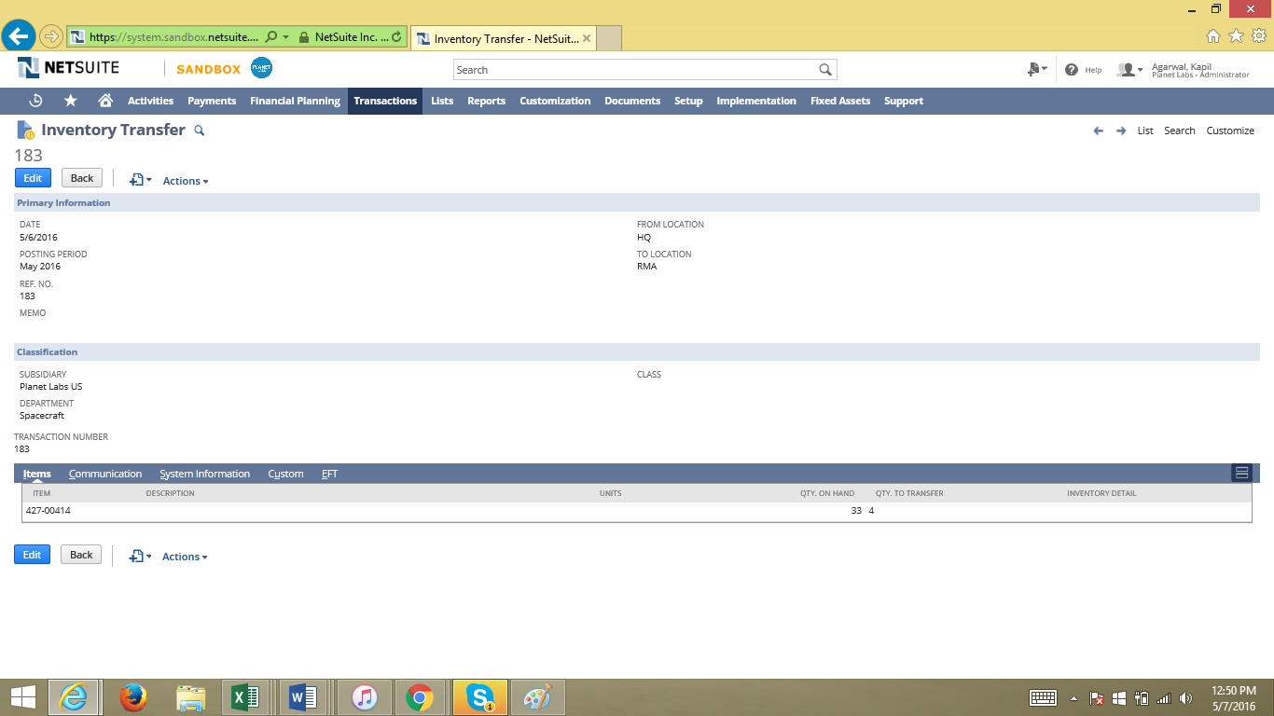

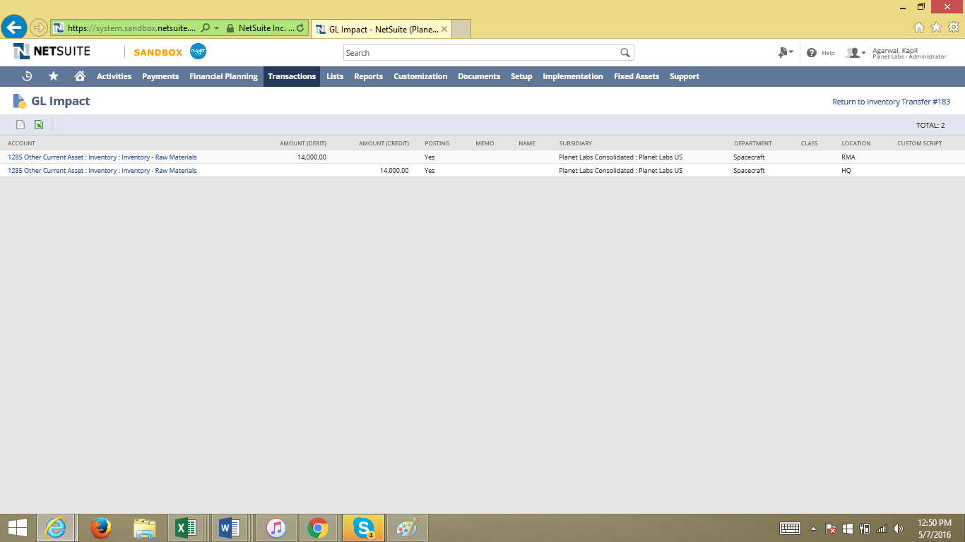

The sample item here does not uses bin.

If the item uses bins, the bin will also transfer from HQ to the RMA bin.